# 06. Clone Git Repo

*For a QA specialist, proficiency in using platforms like GitHub is paramount. It's not just a tool; it represents a modern approach to software development, collaboration, and testing. The following task will test your ability to navigate this platform and execute Python functions.*

## Clone the Repo:

* Use the **Windows Terminal** to **clone the repository** from the provided **link**: <https://github.com/softtechfundexams/RegularExamFebruary2024>

## Navigate and Run the JavaScript Application:

* Once the cloning process is complete, **navigate to the cloned repository directory** using the **terminal**. Use the appropriate command to **change the directo**ry.
* Confirm that you are in the **correct directory** by **listing all the files and folders** present. Execute the command that will **display all the files in the current directory**.
* **Locate** the file named **"book-loan-v4.js"** within the repository.
* **Run the "book-loan-v4.js"** file using the appropriate command to execute a JavaScript file in the terminal.

## How to Send Solutions in Judge?

* The application will print a **Result Message on your console**. Highlight the output **message** and **copy** it, by using the **"CTRL + C"** key combination. Paste the result to Judge and **Submit**.

ANSWER:

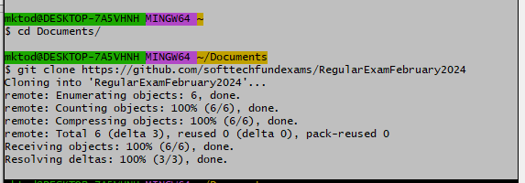

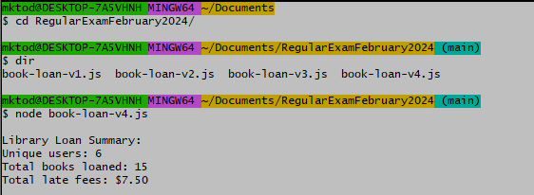

*Your performance in this exam, particularly your attention to detail and problem-solving capabilities, will serve as an indicator of your readiness as a QA specialist. Quality assurance is the bedrock of software reliability, and your commitment to mastery in this field is commendable.*